**What is information?**

Information is stimuli that has meaning in some context for its receiver. When information is entered into and stored in a computer, it is generally referred to as data. After processing -- such as formatting and printing -- output data can again be perceived as information. When information is compiled or used to better understand something or to do something, it becomes knowledge.

The [data-information-knowledge-wisdom model](https://www.techtarget.com/searchitoperations/feature/Evaluate-AI-based-ITSM-tools-using-these-key-points) illustrates this hierarchy. Structured as a pyramid, the model was created to show that data can be captured in different formats, analyzed and converted into different forms. Each level of the pyramid represents a different perspective or level of abstraction as follows:

* The discrete, raw facts about a given situation with no analysis or interpretation applied.
* Applying description and meaning to data to make it useful.
* Information that has insight, context and a frame of reference applied so it can be interpreted.
* Knowledge is converted into wisdom by applying judgment and action to the information.
* 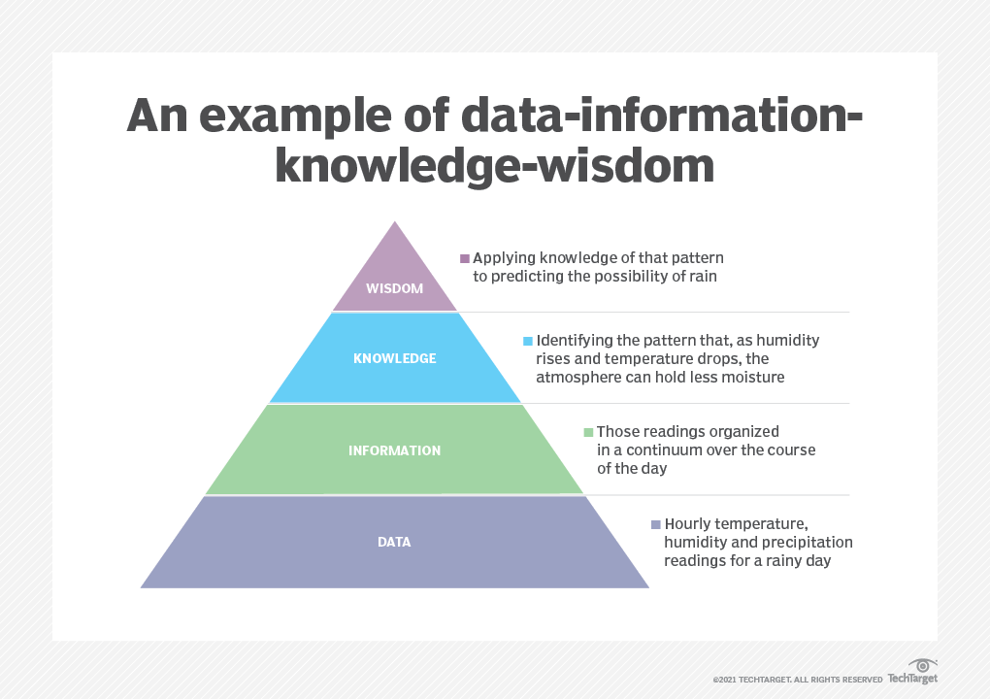

### What is data?

Data refers to the raw information. In the context of information technology (IT) and computing, it is information that a software application collects and records. Data is typically stored in a database and includes the fields, records and other information that make up the database. It can be accessed and manipulated digitally, and it is quick and easy to transfer among computers.

[Data is collected](https://www.techtarget.com/searchcio/definition/data-collection) from a variety of sources, such as computers, sensors and devices. It is typically used in business, science and engineering. Data is often presented in the form of numbers, but it can also come as text, visuals, graphics and sounds. Data can also be analyzed and used to create information that could not be obtained by just looking at the original data.

The most common types of data in data science are the following:

* **Quantitative data** is numerical data, or data that can be expressed mathematically. Discreet and continuous data are types of quantitative data.
* [**Qualitative data**](https://www.techtarget.com/searchcio/definition/qualitative-data) is data that cannot be measured, counted or easily expressed with numbers. It is data that comes from text, audio or images. It can be shared using [data visualization](https://www.techtarget.com/searchbusinessanalytics/definition/data-visualization) tools, such as timelines, infographics and word clouds.
* **Nominal data** is the simplest form of data in statistics. It is data that is used to name or label a variable; it isn't used to measure things or put them in any order. Examples of nominal data include ethnicity, gender, eye color.
* **Ordinal data** is data that takes on values within a known range and follows a natural order. A common example of ordinal data is income levels where incomes are ranked in specific ranges, such as $0-$50K, $50K-$75K, $75K-$100K, etc. The purpose of ordinal data is to rank items in order of priority or value. The numbers are not used for calculations.
* **Discrete data**, also called categorical data, is data that is divided into discrete categories, or groups, that are distinctly different from each other. With discrete data, only a specific number of values are possible, and those values cannot be subdivided. For example, the number of people a company employs is a discrete data point.
* **Continuous data** is a term used to describe data that is measurable and observable in real time. It can be measured on a scale or a continuum and subdivided into finer values. Continuous data is often recorded at set intervals and then analyzed using statistical software. The amount of time it takes to complete a task is an example of continuous data.

### What is the data processing cycle?

The data processing cycle is the framework that data center managers use to make data accessible and useful to users. It is a portion of the [data lifecycle](https://www.techtarget.com/whatis/definition/data-life-cycle). Data enters the data center where it is processed, and then it is sent to the user who makes use of it in a business application.

The part of the data lifecycle referred to as the data processing cycle is divided into the following three stages:

1. This is the stage where data is collected from multiple sources -- point-of-sale locations, call centers and sensors, for example.
2. The data is sorted, organized, cleansed and entered into a database or system. It is then transformed into a format that users can understand and make use of.
3. The newly processed and transformed data is sent to users or stored in a way that they will have access to it when needed.

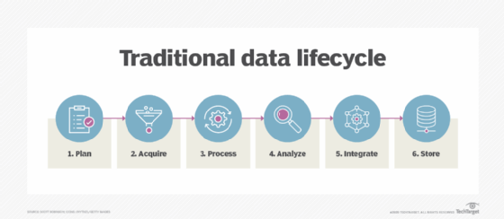

### Converting data to information

Data and information are not the same. Data refers to numerical and qualitative observations. Information is created when data is presented in a way that has meaning to the recipient. To turn data into information, it must be processed and organized. Presenting data in a way that has meaning and value is called information design, and it is an important field in both Information architecture and [human-computer interaction](https://www.techtarget.com/searchsoftwarequality/definition/HCI-human-computer-interaction).

Five characteristics of [data quality](https://www.techtarget.com/searchdatamanagement/definition/data-quality) and high-quality information in a database include the following:

* Information must come from a reliable source of information.
* Information cannot be partial or have details missing.
* Mechanisms must be in place to ensure that new data doesn't contradict existing data.
* Information must be distinctive and add value to a database.
* Information in a database must be timely and up to date.

### Converting information to knowledge and wisdom

Knowledge is information that has been processed, analyzed and interpreted, and can be used to make decisions. The concept of knowledge involves not just the information, but the ability to access it, as well. For example, most applications, including models and simulations, include a form of stored knowledge.

Wisdom is the synthesis of information, knowledge and experience in a way that applies knowledge to real-life situations. The concept of wisdom enables the understanding of patterns and their driving factors. It ultimately enables the [prediction of future events](https://www.techtarget.com/searchenterpriseai/post/Associativity-graphical-summary-computations-aid-ML-insights).

Artificial intelligence ([AI](https://www.techtarget.com/searchenterpriseai/definition/AI-Artificial-Intelligence)) has enabled computers to learn, problem-solve and perform tasks that usually require human intelligence. These technologies enable computers to take actions based on what the data provided indicates is the best course of action. AI is used in [expert systems](https://www.techtarget.com/searchenterpriseai/definition/expert-system) to diagnose disease, buy and sell stock and play chess better than a human. However, IT has not yet attained a level of human wisdom.

## **What is Number System in Maths?**

A number system is defined as a system of writing to express numbers. It is the mathematical notation for representing numbers of a given set by using digits or other symbols in a consistent manner. It provides a unique representation of every number and represents the arithmetic and algebraic structure of the figures. It also allows us to operate arithmetic operations like addition, subtraction, multiplication and division.

The value of any digit in a number can be determined by:

* The digit
* Its position in the number
* The base of the number system

Before discussing the different types of number system examples, first, let us discuss what is a number?

## **What is a Number?**

A number is a mathematical value used for counting or measuring or labelling objects. Numbers are used to performing arithmetic calculations.  Examples of numbers are natural numbers, whole numbers, rational and irrational numbers, etc. 0 is also a number that represents a null value.

A number has many other variations such as even and odd numbers, prime and composite numbers. Even and odd terms are used when a number is divisible by 2 or not, whereas prime and composite differentiate between the numbers that have only two factors and more than two factors, respectively.

In a number system, these numbers are used as digits. 0 and 1 are the most common digits in the number system, that are used to represent binary numbers. On the other hand, 0 to 9 digits are also used for other number systems. Let us learn here the types of number systems.

## **Types of Number Systems**

There are various types of number systems in mathematics. The four most common number system types are:

1. Decimal number system (Base- 10)
2. Binary number system (Base- 2)
3. Octal number system (Base-8)
4. Hexadecimal number system (Base- 16)

Now, let us discuss the different types of number systems with examples.

### Decimal Number System (Base 10 Number System)

The decimal number system has a base of 10 because it uses ten digits from 0 to 9. In the decimal number system, the positions successive to the left of the decimal point represent units, tens, hundreds, thousands and so on. This system is expressed in [decimal numbers](https://byjus.com/maths/decimals/). Every position shows a particular power of the base (10).

**Example of Decimal Number System:**

The decimal number 1457 consists of the digit 7 in the units position, 5 in the tens place, 4 in the hundreds position, and 1 in the thousands place whose value can be written as:

(1×103) + (4×102) + (5×101) + (7×100)

(1×1000) + (4×100) + (5×10) + (7×1)

1000 + 400 + 50 + 7

1457

### Binary Number System (Base 2 Number System)

The base 2 number system is also known as the [Binary number system](https://byjus.com/maths/binary-number-system/) wherein, only two binary digits exist, i.e., 0 and 1. Specifically, the usual base-2 is a radix of 2. The figures described under this system are known as binary numbers which are the combination of 0 and 1. For example, 110101 is a binary number.

We can convert any system into binary and vice versa.

**Example**

Write (14)10 as a binary number.

**Solution:**

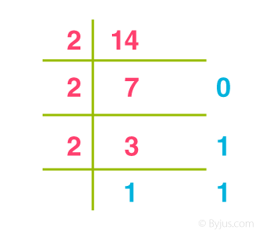

 (14)10 = 11102

### Octal Number System (Base 8 Number System)

In the [octal number system](https://byjus.com/maths/octal-number-system/), the base is 8 and it uses numbers from 0 to 7 to represent numbers. Octal numbers are commonly used in computer applications. Converting an octal number to decimal is the same as decimal conversion and is explained below using an example.

**Example: Convert 2158 into decimal.**

**Solution:**

2158 = 2 × 82 + 1 × 81 + 5 × 80

= 2 × 64 + 1 × 8 + 5 × 1

= 128 + 8 + 5

= 14110

### Hexadecimal Number System (Base 16 Number System)

In the hexadecimal system, numbers are written or represented with base 16. In the hexadecimal system, the numbers are first represented just like in the decimal system, i.e. from 0 to 9. Then, the numbers are represented using the alphabet from A to F. The below-given table shows the representation of numbers in the [hexadecimal number system](https://byjus.com/maths/hexadecimal-number-system/).

|  |  |  |  |  |  |  |  |  |  |  |  |  |  |  |  |  |
| --- | --- | --- | --- | --- | --- | --- | --- | --- | --- | --- | --- | --- | --- | --- | --- | --- |
| **Hexadecimal** | **0** | **1** | **2** | **3** | **4** | **5** | **6** | **7** | **8** | **9** | **A** | **B** | **C** | **D** | **E** | **F** |
| **Decimal** | **0** | **1** | **2** | **3** | **4** | **5** | **6** | **7** | **8** | **9** | **10** | **11** | **12** | **13** | **14** | **15** |

## **Number System Chart**

In the number system chart, the base values and the digits of different number systems can be found. Below is the chart of the numeral system.

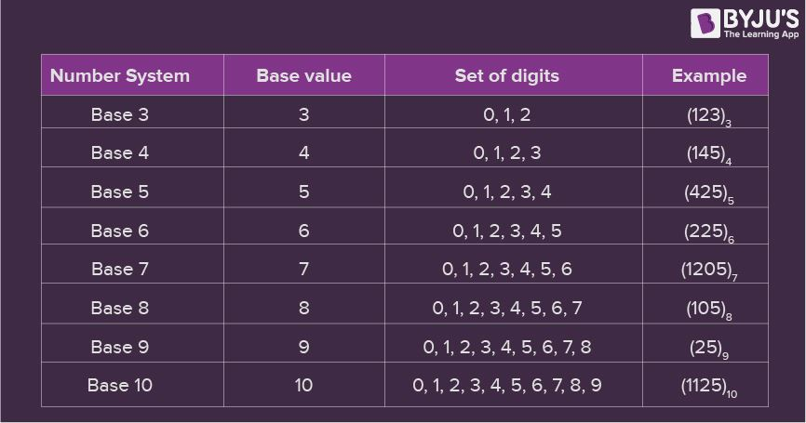

## **Number System Conversion**

Numbers can be represented in any of the number system categories like binary, decimal, hexadecimal, etc. Also, any number which is represented in any of the number system types can be easily converted to another. Check the detailed lesson on the [conversions of number systems](https://byjus.com/maths/number-system-conversion/) to learn how to convert numbers in decimal to binary and vice versa, hexadecimal to binary and vice versa, and octal to binary and vice versa using various examples.

With the help of the different conversion procedures explained above, now let us discuss in brief about the conversion of one number system to the other number system by taking a random number.

Assume the number 349. Thus, the number 349 in different number systems is as follows:

The number 349 in the binary number system is 101011101

The number 349 in the decimal number system is 349.

The number 349 in the octal number system is 535.

The number 349 in the hexadecimal number system is 15D

## **Number System Solved Examples**

**Example 1:**

Convert (1056)16 to an octal number.

**Solution:**

Given, 105616 is a hex number.

First we need to convert the given hexadecimal number into decimal number

(1056)16

= 1 × 163 + 0 × 162 + 5 × 161 + 6 × 160

= 4096 + 0 + 80 + 6

= (4182)10

Now we will convert this decimal number to the required octal number by repetitively dividing by 8.

|  |  |  |
| --- | --- | --- |
| 8 | 4182 | Remainder |
| 8 | 522 | 6 |
| 8 | 65 | 2 |
| 8 | 8 | 1 |
| 8 | 1 | 0 |
|  | 0 | 1 |

Therefore, taking the value of the remainder from bottom to top, we get;

(4182)10 = (10126)8

Therefore,

(1056)16 = (10126)8

**Example 2:**

Convert (1001001100)2 to a decimal number.

**Solution:**

(1001001100)2

= 1 × 29 + 0 × 28 + 0 × 27 + 1 × 26 + 0 × 25 + 0 × 24 + 1 × 23 + 1 × 22 + 0 × 21 + 0 × 20

= 512 + 64 + 8 + 4

= (588)10

**Example 3:**

Convert 101012 into an octal number.

**Solution:**

Given,

 101012 is the binary number

We can write the given binary number as,

010 101

Now as we know, in the octal number system,

010 → 2

101 → 5

Therefore, the required octal number is (25)8

**Example 4:**

Convert hexadecimal 2C to decimal number.

**Solution:**

We need to convert 2C16 into binary numbers first.

2C → 00101100

Now convert 001011002 into a decimal number.

101100 = 1 × 25+ 0 × 24 + 1 × 23+ 1 × 22 + 0 × 21 + 0 × 20

= 32 + 8 + 4

= 44

**Problem**: Suppose 560 is a decimal number, convert it into an octal number.

**Solution**: If 560 is a decimal number, then,

560/8 = 70 and the remainder is 0

70/8 = 8 and the remainder is 6

8/8 = 1 and the remainder is 0

And 1/8 = 0 and the remainder is 1

So the octal number starts from MSD to LSD, i.e. 1060

Therefore, 56010 = 10608

### Computer Numeral System (Number System in Computers)

When we type any letter or word, the computer translates them into numbers since computers can understand only numbers. A computer can understand only a few symbols called digits and these symbols describe different values depending on the position they hold in the number. In general, the binary number system is used in computers. However, the octal, decimal and hexadecimal systems are also used sometimes.

## **Frequently Asked Questions on Number System**

### What is Number System and its Types?

The number system is simply a system to represent or express numbers. There are various types of number systems and the most commonly used ones are decimal number system, binary number system, octal number system, and hexadecimal number system.

### Why is the Number System Important?

The number system helps to represent numbers in a small symbol set. Computers, in general, use binary numbers 0 and 1 to keep the calculations simple and to keep the amount of necessary circuitry less, which results in the least amount of space, energy consumption and cost.

### What is Base 1 Number System Called?

The base 1 number system is called the unary numeral system and is the simplest numeral system to represent natural numbers.

### What is the equivalent binary number for the decimal number 43?

To find the equivalent binary number, we need to divide 43 by 2, until we get 0 as the result. Therefore, (43)10 = 1010112

### How to convert 308 into a decimal number?

308 = (3 × 81) + (0 × 80) = 24